EXPERIMENT-1
Aim
To simulate and compare FDMA, TDMA and CDMA resource allocation, estimated user capacity and CDMA SIR.
Procedure
- Open MATLAB and create a new script.
- Enter total bandwidth, FDMA channel width, TDMA slots, CDMA processing gain and target SIR.
- Run the capacity and SIR program; inspect the printed values and plots.
- Run the generation-comparison and resource-allocation programs below.
- Change one parameter and rerun; compare the results.

Objective 1 – Capacity estimate and CDMA SIR plot
MATLAB Program
clear; clc; close all;
totalBandwidthHz = 1e6;
fdmaChannelHz = 200e3;
tdmaSlots = 8;
processingGain = 64;
targetSIRdB = 7;

fdmaUsers = floor(totalBandwidthHz/fdmaChannelHz);
tdmaUsers = tdmaSlots;
targetSIR = 10^(targetSIRdB/10);
cdmaUsers = floor(1 + processingGain/targetSIR);

fprintf('FDMA users = %d\n',fdmaUsers);
fprintf('TDMA users = %d\n',tdmaUsers);
fprintf('CDMA estimated users = %d\n',cdmaUsers);

K = 2:30;
sirDb = 10*log10(processingGain./(K-1));
figure; plot(K,sirDb,'o-'); hold on;
yline(targetSIRdB,'--r','Target SIR');
grid on; xlabel('Number of CDMA users');
ylabel('Estimated SIR (dB)');
title('CDMA SIR versus Number of Users'); hold off;

methods = categorical(["FDMA","TDMA","CDMA"]);
users = [fdmaUsers tdmaUsers cdmaUsers];
figure; bar(methods,users); grid on;
ylabel('Estimated users'); title('Capacity Comparison');
OUTPUT:
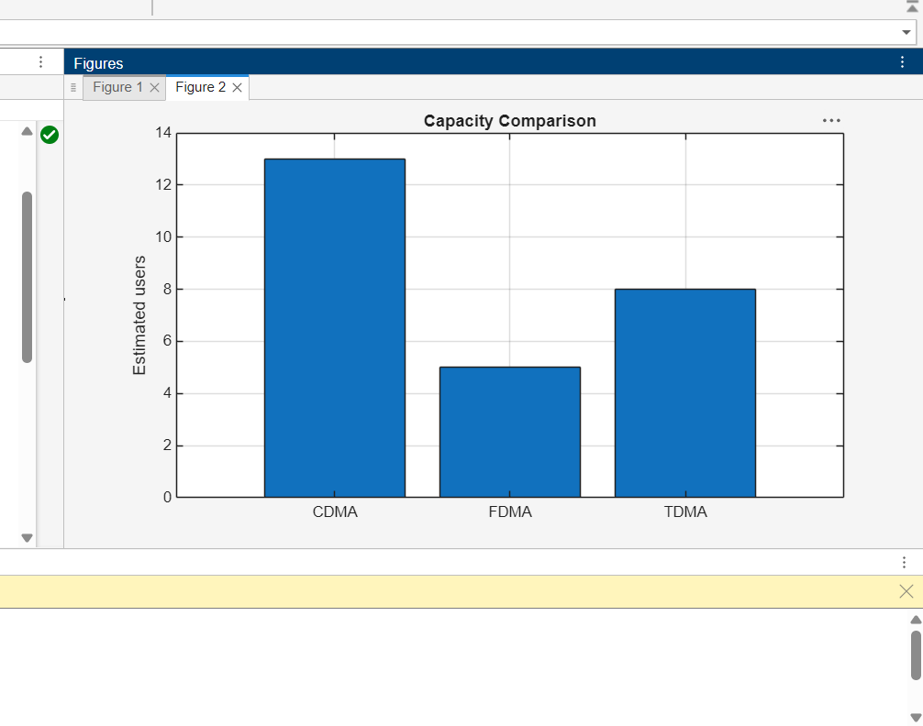

Objective 2: CDMA SIR analysis:
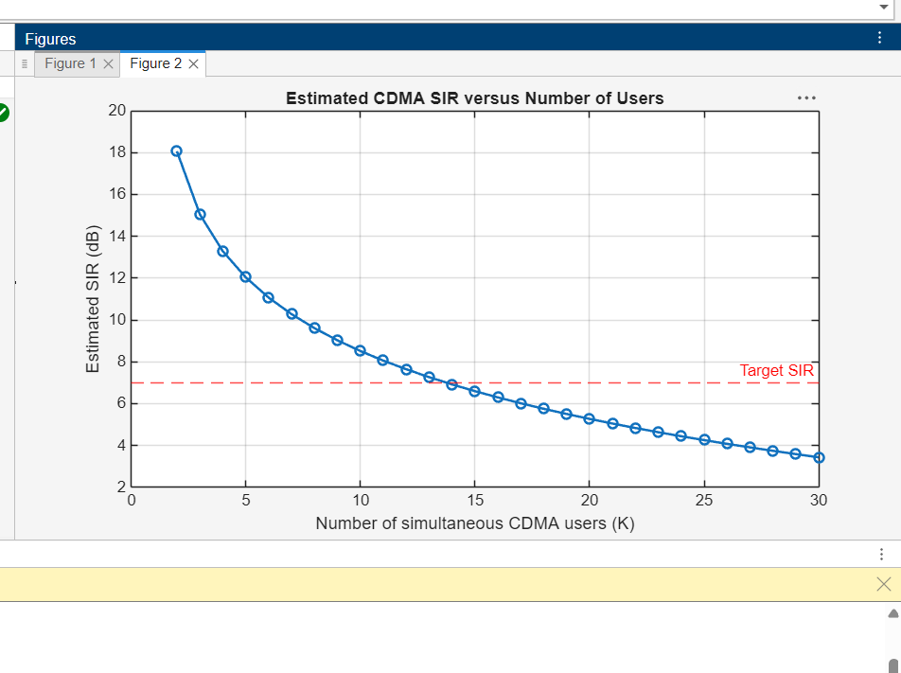

Objective 3: Mobile-generation comparison:
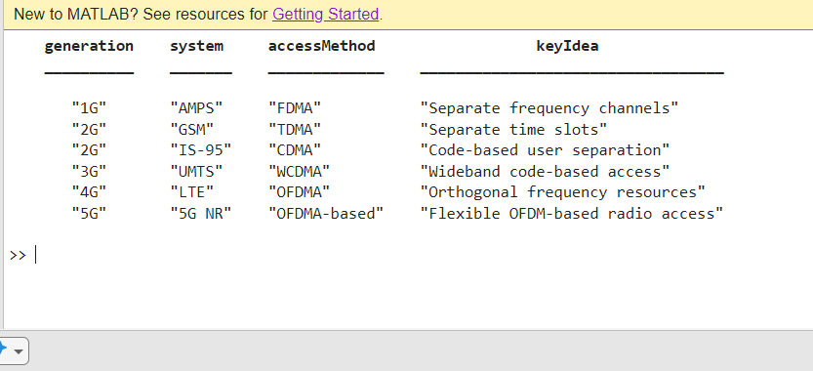

Objective 4: Resource-allocation diagrams:
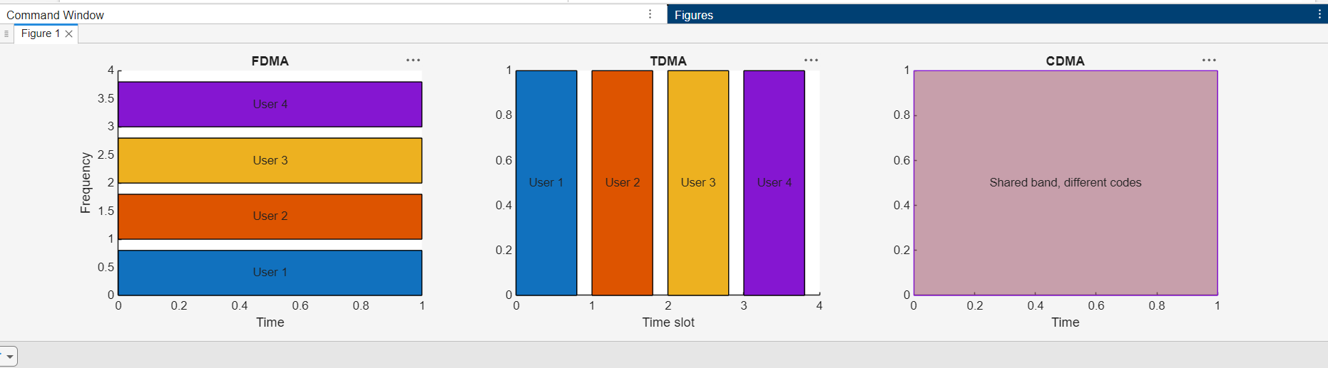
Result
FDMA, TDMA and CDMA resource allocation was illustrated. The estimated CDMA SIR decreases as the number of simultaneous users increases. The results depend on the simplified assumptions.

